PRP Design Document

Introduction
Based on the research, i have designed a segmented Azure network for Fonteyn Holiday Parks. The design focuses on reducing lateral movement, preventing unauthorized access between services, improving visibility through monitoring, and using Zero Trust principles.
The design uses a Hub-and-Spoke architecture in Azure where centralized security services are in a Hub Virtual Network and workloads are separated into individual Spoke Virtual Networks.

High-Level Architecture
The design includes:
- One Hub Virtual Network
- Multiple Spoke Virtual Networks
- VNet Peering
- Network Security Groups (NSGs)
- Azure Monitor
- Log Analytics Workspace
- NSG Flow Logs
- Infrastructure as Code using Bicep

Hub Virtual Network Design
The hub is used as a centralised point of connectivity withing the enviroment
It contains:
- Azure Firewall
- Azure Bastion
- VPN Gateway
- Monitoring resources

Justification
Research showed that a Hub-and-Spoke architecture provides stronger segmentation compared to a flat network design. Some benefits are centralized security controls, easier management and better scalability
By routing all traffic trough, the hub security measures can be applied consistently across the whole environment

Spoke Network Design
Separated spoke networks are created for different workloads
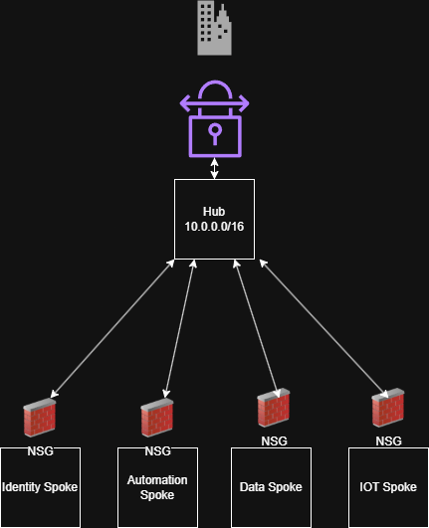
Automation Spoke:
Ahmed has an web app program that deploys bicep templates for services which he created for his PRP

IOT Spoke
For the future an IOT spoke can be created for things like the barrier system

Identity Spoke
This is the most important and has to be most isolated it includes the core services such as AD, DNS

Reservation Spoke
Spoke that has been created to host the reservation service which includes a Azure SQL Database and Web App. This will later be used by Linards for his individual PRP

Justification
Research showed that lateral movement is one of the largest security risks
By separating workloads to dedicated spokes reduces the possibility of attackers moving freely throughout the environment after there has been a compromission of a system.

Subnets
Every spoke contains the following subnets:
Application subnet
- Hosts Applications
Management Subnet
- Adminitstrative access
Future expainsion Subnet
- Reserved for scalsability

Justification
Subnets separation allows security controls to be applied more precisely and supports future expansion of the environment

Network Security Group Design
NSGs are applied at subnet level
The design follows a deny by default approach which follows ZTA principles in which it makes it so everything is not trusted by default unless you allow it

An example is:
Priority | Source | Destignation | Action
100 | Management subnet | Servers | Allow
200 | Production subnet | Required services | Allow
300 | Any | Any | Deny

VNet Peering Design

The Hub VNet is connected to all spoke networks using VNet Peering
Spoke to Spoke communication is not directly allowed

Justification
This prevents unnecessary communication between networks and limits the opportunities for lateral movement

Monitor design
Monitoring is implemented through Azure Monitor, Log Analytics Workspace and NSG Flow Logs
Monitored Events
- Allowed traffic
- Denied traffic
- Unusual communication patterns
- Unauthorized access attempts
Justification
Research demonstrated that segmentation alone is insufficient.
Monitoring is required to detect:
- Port scanning
- Unauthorized access attempts
- Potential lateral movement

Infrastructure as Code Design
The complete network environment is deployed using Bicep templates.
The templates deploy:
- Virtual Networks
- Subnets
- NSGs
- Monitoring resources
- Peering connections
Justification
Research shows that there can be misconfigurations when manually deploying azure resources.
Using Bicep ensures:
- Repeatable deployments
- Consistent security settings
- Reduced human error
- Faster deployment

Security Design Principles
The architecture is based on the following principles:
Network Segmentation
Resources are separated using Hub-and-Spoke architecture, VNets, and subnets.
Least Privilege
Only required communication is permitted.
Zero Trust
No resource is trusted by default, even when located inside the Azure environment.
Visibility
Monitoring and logging are enabled throughout the infrastructure.

Design Conclusion
The design for the Azure architecture shows the risks that have been identified during my research. Trough a combination of Hub-and-spoke networking, NSGs, ZTA principles, monitoring and IaC the infrastructure is secured stronger to risks like Lateral movement, unauthorized access and malware propagation while remaining the scalable and manageable infrastructure Fonteyn needs.

